Determine electric connections of the process in open loop.
Let´s start explaining what is an open loop. The open loop system creates a variable output that is determined by the setpoint. This system does not have any means for sensing the actual output value.
The advantages of open loop systems are that they are usually simpler and cost less than closed loop systems and the disadvantages are it cannot continue to maintain the desired level if conditions change.
Open loop systems are used in applications where exact control is not critical and there is not much change in conditions.
To create an open loop in the Process Control System follow the next steps:
- Check the reservoir tank level to make sure it is above 4 inches from the top of the tank,
- Make sure your AMATROL T552 station looks like the Figure 1
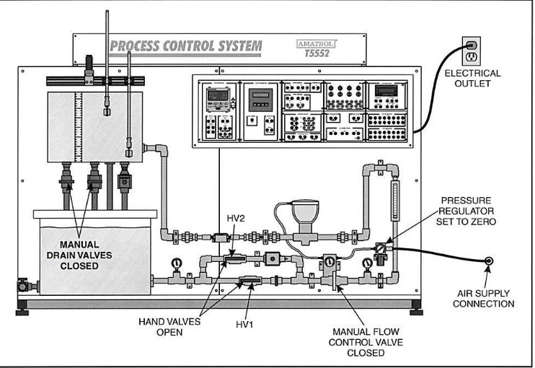
Figure 1:Amatrol T5552 Setup from Manual Control (Taken from manual 1)
- Air supply line is connected to the AMATROL T5552,
- For controling the circulation of the pump, it must be connected the same as Figure2.

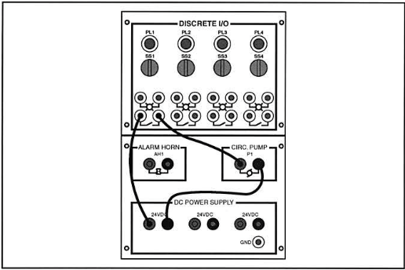
Figure 2: Circuit to control de circulation pump (Taken from Manual 1)

- To turn on the pump look at the next Figure 3:
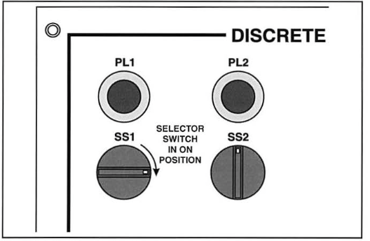
Figure 3: Turn SS1 to the right (Taken from Manual1)
- When the pump its turn on, the level tank start to increase, when that happens open the manual flow control valve. Automatically the Rotameter indicates a Flow rate of 1.5 gpm (Shown in the video1 )
- When the level in the process tank reaches 5 inches, open the right-side hand drain valve of the process tank about halfway, as shown in Figure 4
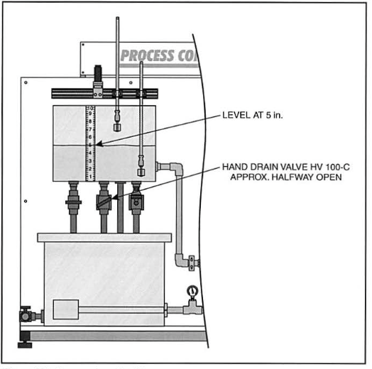
Figure 4: Hand drain valve open halfway(Taken from manual1)

- The flow increases into the process tank by adjusting the manual flow control valve until the level returns to and stabilizes at 5 inches.

This demonstrates the ability to control liquid level with open loop control.

Perform experiments for testing the sensors and actuators which constitute the chosen system.
Ultrasonic Level Sensor
An ultrasonic level sensor is a radiation-based level-measuring device that uses the transmission and reflection of ultrasonic waves to determine the level of material in a container.
They are normally used in applications that require the sensor to not touch the material because of possible contamination. For example in the pharmaceutical industry.
- To test the ultasonic , the amatrol station must be as the next figure 5:
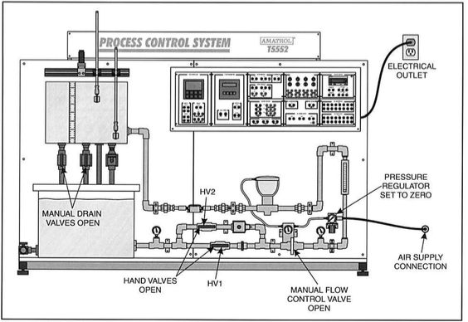
Figure 5: AMATROL T5552

- The circuit assemble in the figure 6 .This circuit allows you to measure the level in the process tank using the ultrasonic level sensor. It also allows you to measure the output from the ultrasonic sensor using a multimeter or loop calibrator. The ultrasonic level sensor is wired in the inverted configuration.
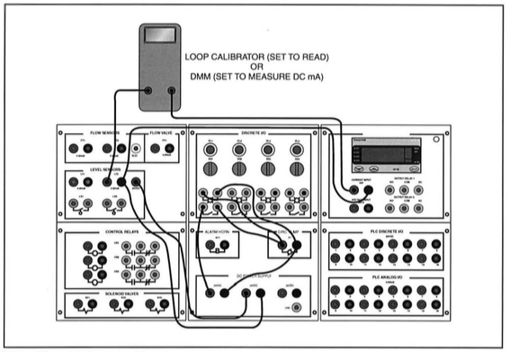

Figure 6 : Level Measuring Circuit (Taken from the manual)

- Record the value of the sensor output from the multimeter or loop calibrator with the tank empty.
The sensor output was of 20.3 mAp. The minimum output should be of 4 mAp but the sensor was not calibrated.
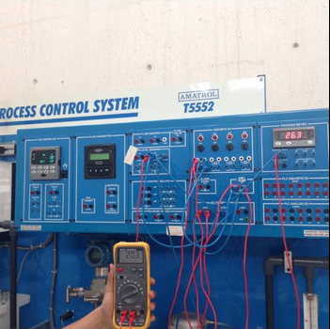

- Later we lose the process tank manual drain valves so the liquid level will increase. When the level reaches approximately 2 inches on the process tank sight scale, turn off selector switch SSl to stop the pump.
The sensor output was still of 20.3 mAp. Later we relized that the Ultrasonic Level Sensor did not work.
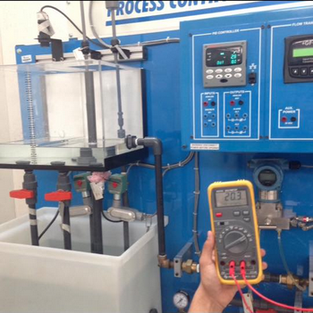

Connect and operate a variable capacitance pressure sensor
Pressure sensor is a variable capacitance pressure sensor. This sensor uses a change in capacitance to create an electrical output signal that is proportional to pressure.
Use the following steps for activating the pressure sensor:
- To test the pressure sensor, make sure the AMATROL station is the same as the next figure6
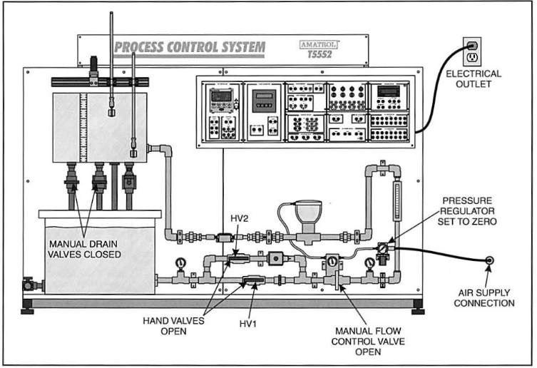
Figure 6

- Set the pressure regulator to 0 psi.
- Fill the reservoir tank with water. Assemble thecicuit shown in Figure 7 . his circuit allows you to control the flow into the process tank using the hand valves or by turning the pump on and off.

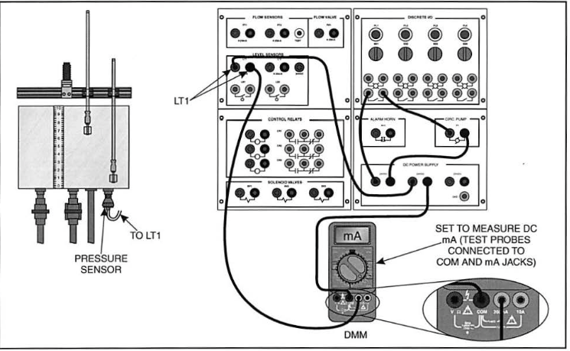
Figure 7 : Circuit to Measure Pressure Sensor Output (Taken from manual 6)
In the last step of connecting the multimeter to make sure the Pressure Sensor is working. The team members realized that the multmeter was no showing anything, so they tried with another multimeter and the result was the same. The team realized that the problema was the pressure sensor that was not working.
